Sri Lanka Institute of Information Technology



# Software Engineering Process & Quality Management

**SE3010**

**Cypress Lab Sheet**

IT22251114 JINAD INDUWITHWA A.G

Initialize a new Node.js project

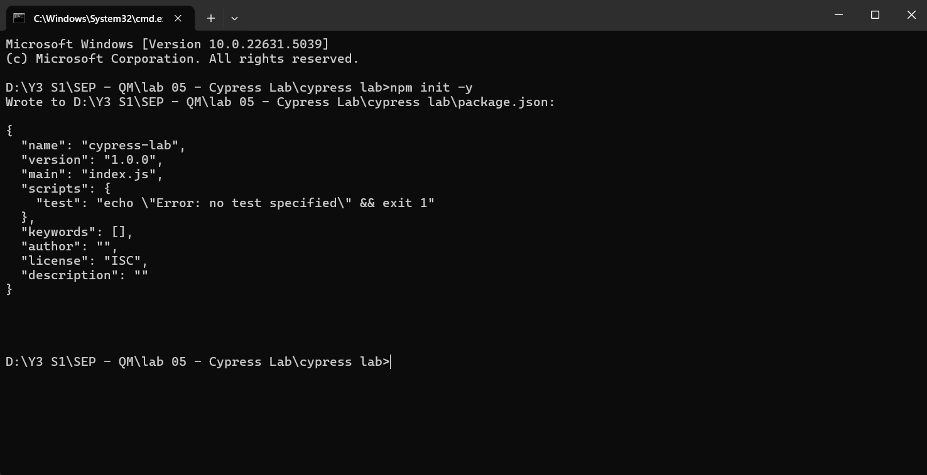

Install cypress

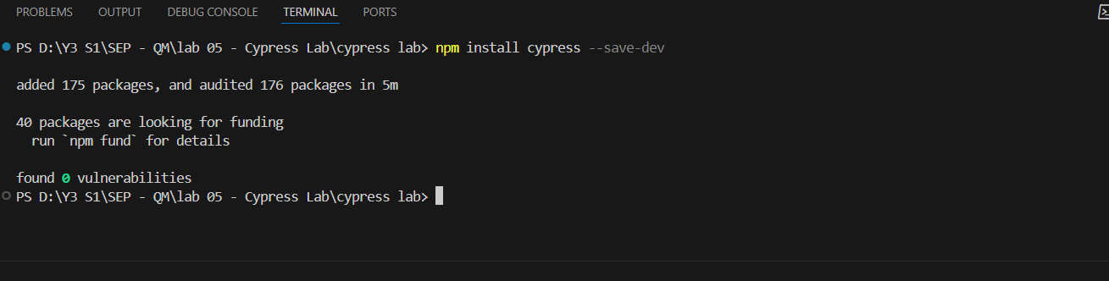

Open cypress

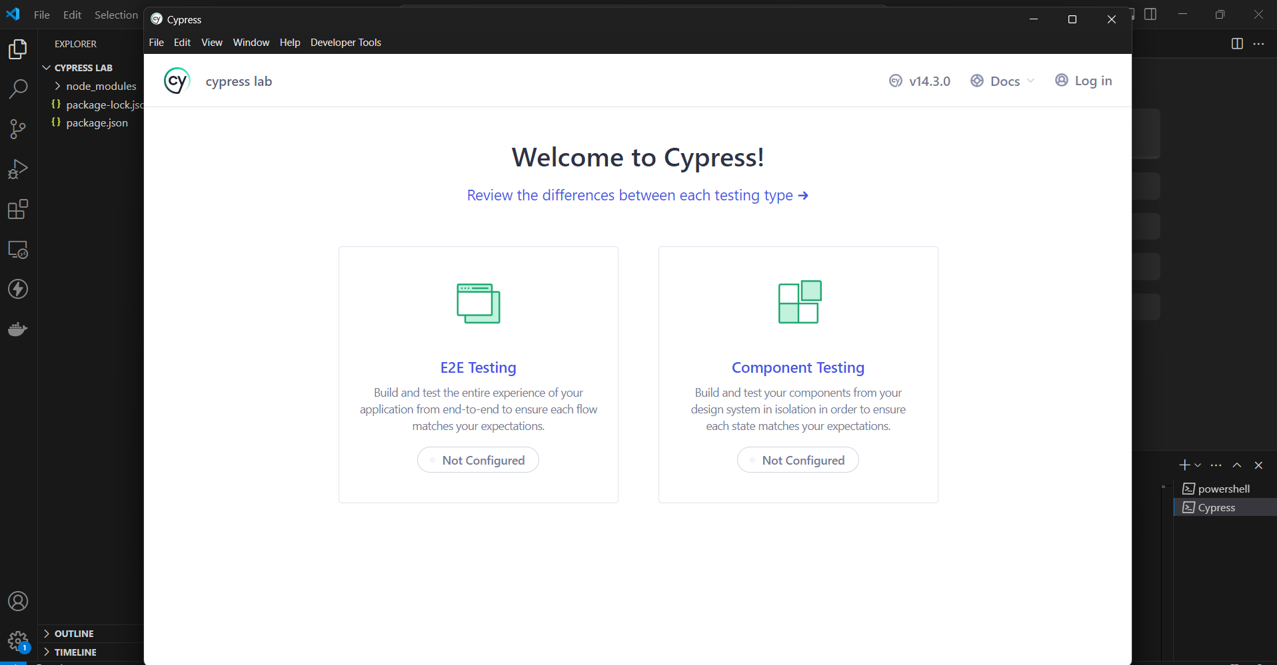

E2E testing

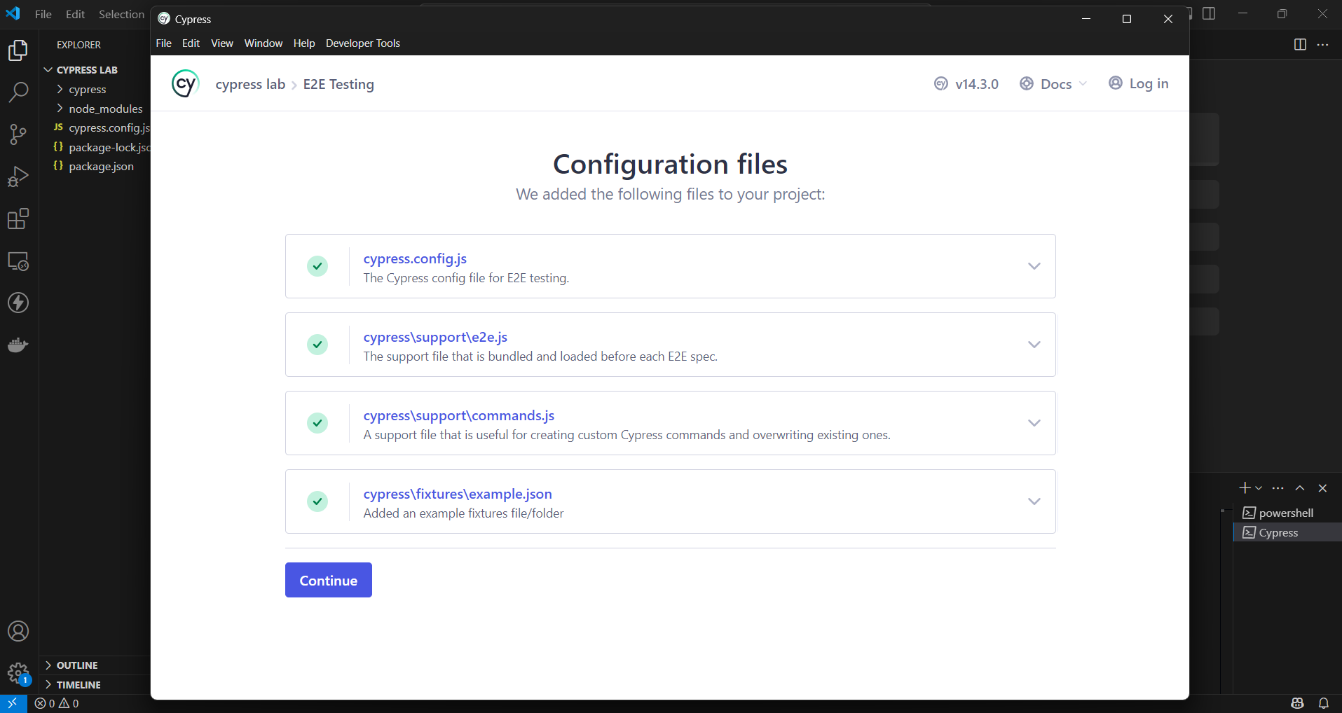

Start testing

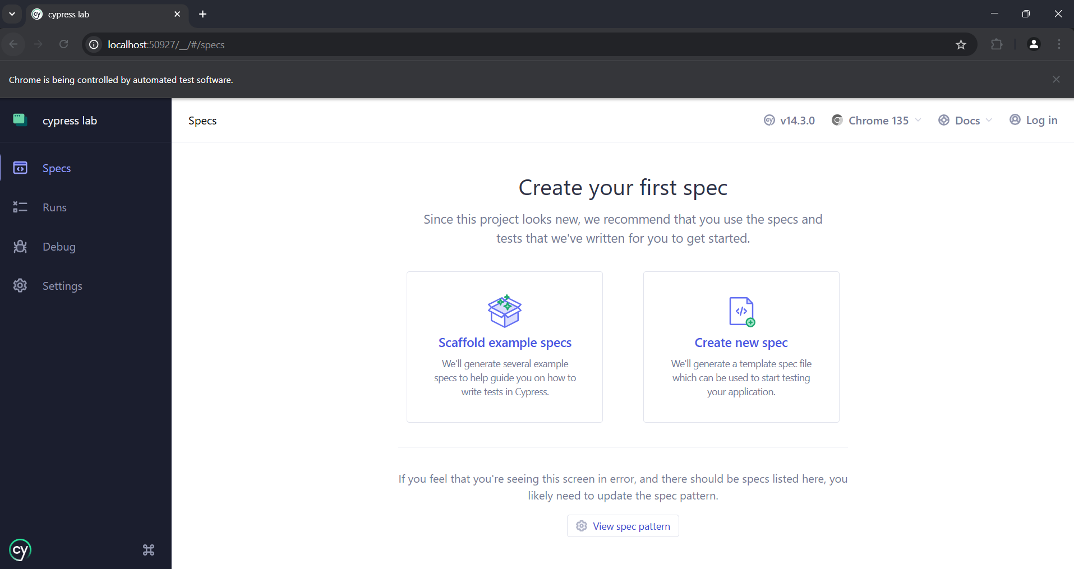

cypress/e2e folder, inside simple_test.cy.js. file

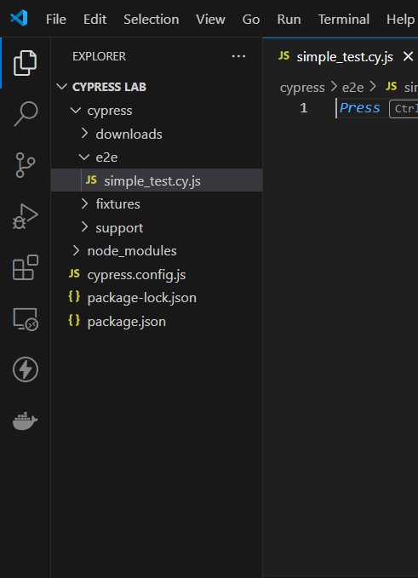

Test scripts

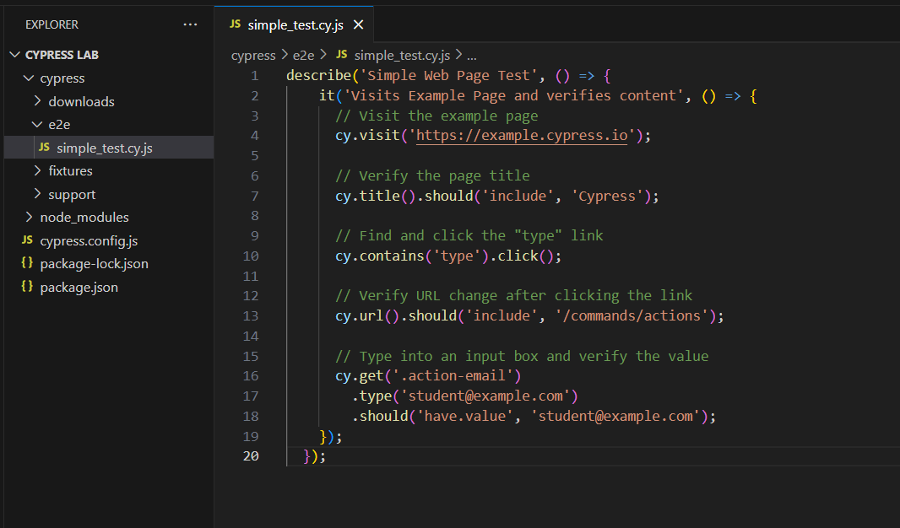

Open cypress again

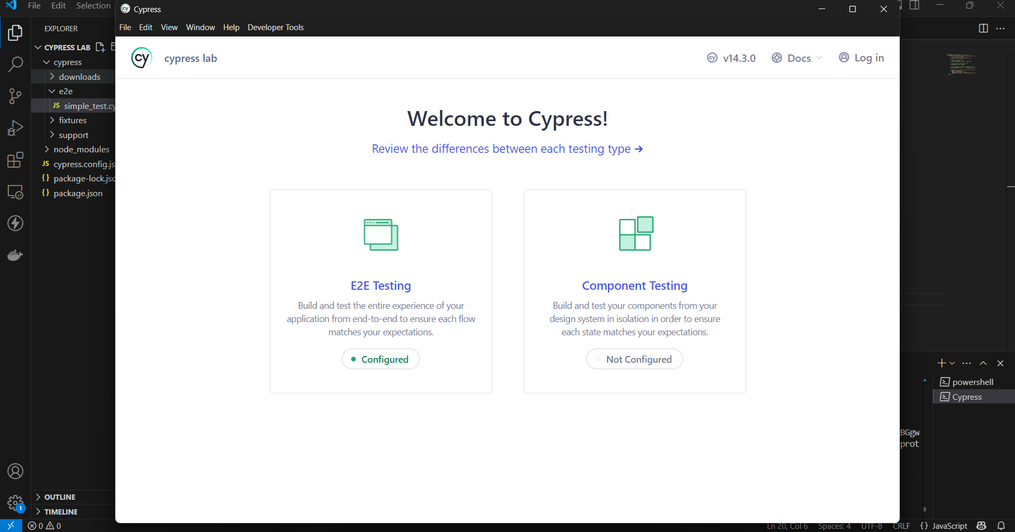

e2e testing and select browser

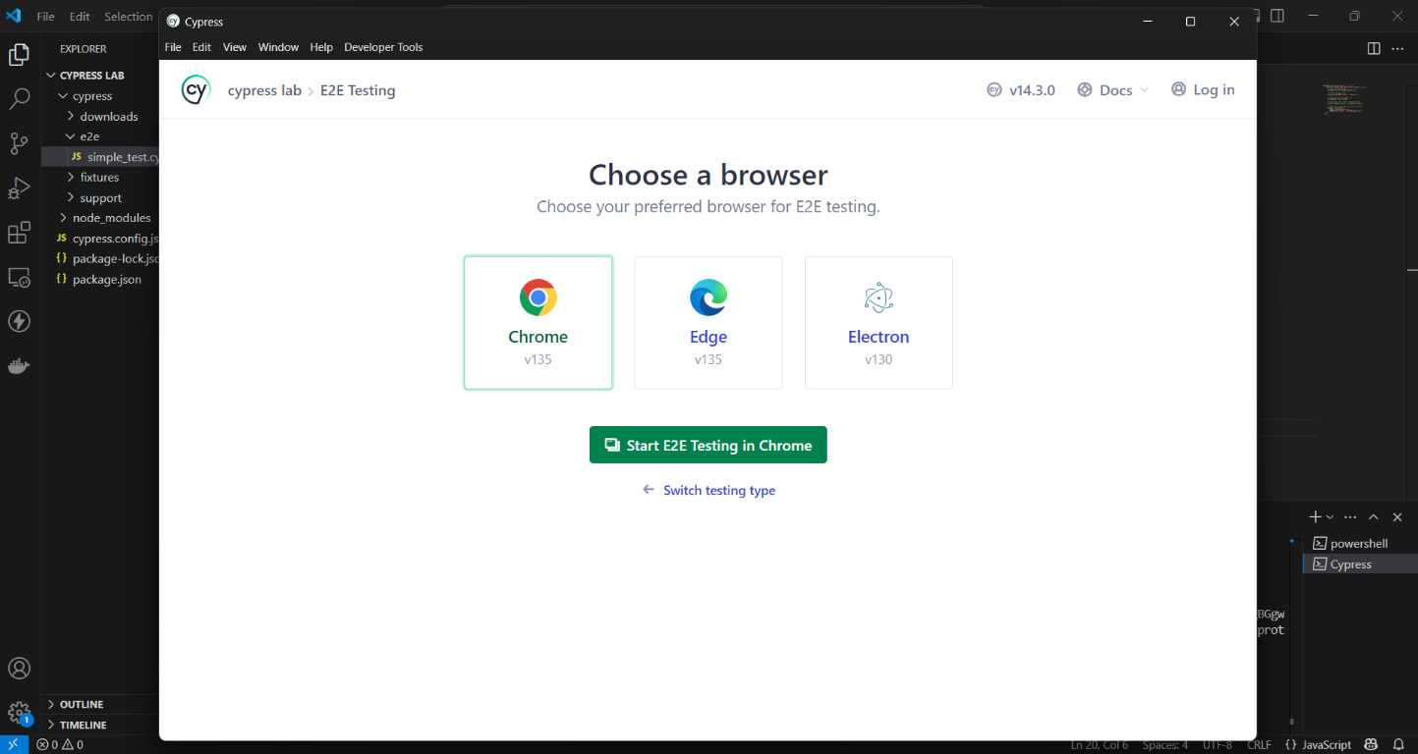

Run the test

